Evaluating Endophyte-Rich Leaves and Leaf Functional Traits for Protection of Tropical Trees Against Natural Enemies

Bolívar Aponte Rolón1,✉, A. Elizabeth Arnold2, Mareli Sánchez Juliá1, and Sunshine A. Van Bael1,1

1 Department of Ecology and Evolutionary Biology, Tulane University, 6823 St. Charles Avenue, New Orleans, LA 70118  
2 School of Plant Sciences, Department of Ecology and Evolutionary Biology, Robert L. Gilbertson Mycological Herbarium. Ecosystem Genomics Graduate Interdisciplinary Program, and the Bio5 Institute, University of Arizona, Tucson, AZ 85721  
3 Department of Ecology and Evolutionary Biology and the Bio5 Institute, University of Arizona, Tucson, AZ 85721

# Supplementary Materials

|  |  |  |  |  |
| --- | --- | --- | --- | --- |
| **Table S1: Student's t-Tests of mean anthocyanins (ACI)**  Pairwise comparisons of ACI between species. | | | | |
|  | *p* - values | | | |
| **Comparison Species*1*** | **p** | **p.adj** | **p.format** | **p.signif*2*** |
| ***A. membranacea*** | | | | |
| *C. cainito* | **2.636 × 10^-16** | **4.500 × 10^-15** | **0** | **\*\*\*\*** |
| *C. alliodora* | **3.713 × 10^-15** | **5.600 × 10^-14** | **0** | **\*\*\*\*** |
| *Dipteryx* sp. | **2.296 × 10^-6** | **1.600 × 10^-5** | **0** | **\*\*\*\*** |
| *H. concinna* | **6.179 × 10^-6** | **3.700 × 10^-5** | **0** | **\*\*\*\*** |
| *L. panamensis* | **1.538 × 10^-2** | **4.600 × 10^-2** | **0.02** | **\*** |
| *T. cacao* | **9.137 × 10^-8** | **8.200 × 10^-7** | **0** | **\*\*\*\*** |
| ***C. cainito*** | | | | |
| *C. alliodora* | **3.154 × 10^-23** | **6.300 × 10^-22** | **< 2e-16** | **\*\*\*\*** |
| *Dipteryx* sp. | **4.559 × 10^-10** | **5.000 × 10^-9** | **0** | **\*\*\*\*** |
| *H. concinna* | 5.309 × 10^-1 | 5.300 × 10^-1 | 0.53 | ns |
| *L. panamensis* | **1.599 × 10^-11** | **2.200 × 10^-10** | **0** | **\*\*\*\*** |
| *T. cacao* | **3.656 × 10^-22** | **6.900 × 10^-21** | **< 2e-16** | **\*\*\*\*** |
| ***C. alliodora*** | | | | |
| *Dipteryx* sp. | **1.150 × 10^-26** | **2.400 × 10^-25** | **< 2e-16** | **\*\*\*\*** |
| *H. concinna* | **7.276 × 10^-11** | **9.500 × 10^-10** | **0** | **\*\*\*\*** |
| *L. panamensis* | **2.486 × 10^-15** | **4.000 × 10^-14** | **0** | **\*\*\*\*** |
| *T. cacao* | **1.428 × 10^-7** | **1.100 × 10^-6** | **0** | **\*\*\*\*** |
| ***Dipteryx* sp.** | | | | |
| *H. concinna* | **3.050 × 10^-3** | **1.200 × 10^-2** | **0** | **\*\*** |
| *L. panamensis* | 6.646 × 10^-2 | 1.300 × 10^-1 | 0.07 | ns |
| *T. cacao* | **3.807 × 10^-18** | **6.900 × 10^-17** | **< 2e-16** | **\*\*\*\*** |
| ***H. concinna*** | | | | |
| *L. panamensis* | **3.062 × 10^-4** | **1.500 × 10^-3** | **0** | **\*\*\*** |
| *T. cacao* | **5.704 × 10^-9** | **5.700 × 10^-8** | **0** | **\*\*\*\*** |
| ***L. panamensis*** | | | | |
| *T. cacao* | **3.583 × 10^-10** | **4.300 × 10^-9** | **0** | **\*\*\*\*** |
| *1* *n* = 156 individuals | | | | |
| *2*Significance levels are represented by *ast*erisks [*p* < .05 (*), *p* <= .01 (\*\**)*, *p* <= .001 (\**\*\*)*, and *p* < .0001 (****)]. | | | | |

|  |  |  |  |  |
| --- | --- | --- | --- | --- |
| **Table S2: Student's t-Tests of mean leaf thickness (LT) (μm)**  Pairwise comparisons of LT between species. | | | | |
|  | *p* - values | | | |
| **Comparison Species*1*** | **p** | **p.adj** | **p.format** | **p.signif*2*** |
| ***A. membranacea*** | | | | |
| *C. cainito* | **1.793 × 10^-8** | **2.300 × 10^-7** | **0** | **\*\*\*\*** |
| *C. alliodora* | **6.857 × 10^-8** | **8.200 × 10^-7** | **0** | **\*\*\*\*** |
| *Dipteryx* sp. | **7.836 × 10^-18** | **1.500 × 10^-16** | **< 2e-16** | **\*\*\*\*** |
| *H. concinna* | **1.255 × 10^-5** | **1.000 × 10^-4** | **0** | **\*\*\*\*** |
| *L. panamensis* | 4.986 × 10^-1 | 1 | 0.5 | ns |
| *T. cacao* | **1.604 × 10^-6** | **1.400 × 10^-5** | **0** | **\*\*\*\*** |
| ***C. cainito*** | | | | |
| *C. alliodora* | 7.854 × 10^-1 | 1 | 0.79 | ns |
| *Dipteryx* sp. | **2.605 × 10^-19** | **5.200 × 10^-18** | **< 2e-16** | **\*\*\*\*** |
| *H. concinna* | 6.876 × 10^-2 | 4.800 × 10^-1 | 0.07 | ns |
| *L. panamensis* | **1.382 × 10^-12** | **2.100 × 10^-11** | **0** | **\*\*\*\*** |
| *T. cacao* | 4.765 × 10^-1 | 1 | 0.48 | ns |
| ***C. alliodora*** | | | | |
| *Dipteryx* sp. | **8.662 × 10^-17** | **1.500 × 10^-15** | **< 2e-16** | **\*\*\*\*** |
| *H. concinna* | 1.347 × 10^-1 | 8.100 × 10^-1 | 0.14 | ns |
| *L. panamensis* | **1.161 × 10^-10** | **1.600 × 10^-9** | **0** | **\*\*\*\*** |
| *T. cacao* | 6.481 × 10^-1 | 1 | 0.65 | ns |
| ***Dipteryx* sp.** | | | | |
| *H. concinna* | **8.177 × 10^-17** | **1.500 × 10^-15** | **< 2e-16** | **\*\*\*\*** |
| *L. panamensis* | **8.008 × 10^-32** | **1.700 × 10^-30** | **< 2e-16** | **\*\*\*\*** |
| *T. cacao* | **4.639 × 10^-13** | **7.400 × 10^-12** | **0** | **\*\*\*\*** |
| ***H. concinna*** | | | | |
| *L. panamensis* | **7.274 × 10^-7** | **7.300 × 10^-6** | **0** | **\*\*\*\*** |
| *T. cacao* | 3.649 × 10^-1 | 1 | 0.37 | ns |
| ***L. panamensis*** | | | | |
| *T. cacao* | **1.707 × 10^-7** | **1.900 × 10^-6** | **0** | **\*\*\*\*** |
| *1* *n* = 156 individuals | | | | |
| *2*Significance levels are represented by *ast*erisks [*p* < .05 (*), *p* <= .01 (\*\**)*, *p* <= .001 (\**\*\*)*, and *p* < .0001 (****)]. | | | | |

|  |  |  |  |  |
| --- | --- | --- | --- | --- |
| **Table S3: Student's t-Tests of mean leaf punch strength (LPS) (N mm-1)**  Pairwise comparisons of LPS between species. | | | | |
|  | *p* - values | | | |
| **Comparison Species*1*** | **p** | **p.adj** | **p.format** | **p.signif*2*** |
| ***A. membranacea*** | | | | |
| *C. cainito* | **9.032 × 10^-36** | **1.600 × 10^-34** | **< 2e-16** | **\*\*\*\*** |
| *C. alliodora* | 3.180 × 10^-1 | 3.200 × 10^-1 | 0.32 | ns |
| *Dipteryx* sp. | **3.538 × 10^-43** | **7.400 × 10^-42** | **< 2e-16** | **\*\*\*\*** |
| *H. concinna* | **7.548 × 10^-21** | **8.700 × 10^-20** | **< 2e-16** | **\*\*\*\*** |
| *L. panamensis* | **7.304 × 10^-26** | **1.200 × 10^-24** | **< 2e-16** | **\*\*\*\*** |
| *T. cacao* | **7.242 × 10^-21** | **8.700 × 10^-20** | **< 2e-16** | **\*\*\*\*** |
| ***C. cainito*** | | | | |
| *C. alliodora* | **3.873 × 10^-39** | **7.700 × 10^-38** | **< 2e-16** | **\*\*\*\*** |
| *Dipteryx* sp. | **3.649 × 10^-16** | **2.200 × 10^-15** | **0** | **\*\*\*\*** |
| *H. concinna* | **6.101 × 10^-12** | **2.400 × 10^-11** | **0** | **\*\*\*\*** |
| *L. panamensis* | **3.975 × 10^-28** | **6.800 × 10^-27** | **< 2e-16** | **\*\*\*\*** |
| *T. cacao* | **7.651 × 10^-21** | **8.700 × 10^-20** | **< 2e-16** | **\*\*\*\*** |
| ***C. alliodora*** | | | | |
| *Dipteryx* sp. | **1.738 × 10^-36** | **3.300 × 10^-35** | **< 2e-16** | **\*\*\*\*** |
| *H. concinna* | **1.267 × 10^-21** | **1.600 × 10^-20** | **< 2e-16** | **\*\*\*\*** |
| *L. panamensis* | **8.205 × 10^-21** | **8.700 × 10^-20** | **< 2e-16** | **\*\*\*\*** |
| *T. cacao* | **1.371 × 10^-22** | **1.900 × 10^-21** | **< 2e-16** | **\*\*\*\*** |
| ***Dipteryx* sp.** | | | | |
| *H. concinna* | **1.617 × 10^-15** | **8.100 × 10^-15** | **0** | **\*\*\*\*** |
| *L. panamensis* | **7.768 × 10^-26** | **1.200 × 10^-24** | **< 2e-16** | **\*\*\*\*** |
| *T. cacao* | **3.965 × 10^-7** | **8.800 × 10^-7** | **0** | **\*\*\*\*** |
| ***H. concinna*** | | | | |
| *L. panamensis* | **2.293 × 10^-18** | **1.800 × 10^-17** | **< 2e-16** | **\*\*\*\*** |
| *T. cacao* | **1.173 × 10^-17** | **8.200 × 10^-17** | **< 2e-16** | **\*\*\*\*** |
| ***L. panamensis*** | | | | |
| *T. cacao* | **2.949 × 10^-7** | **8.800 × 10^-7** | **0** | **\*\*\*\*** |
| *1* *n* = 156 individuals | | | | |
| *2*Significance levels are represented by *ast*erisks [*p* < .05 (*), *p* <= .01 (\*\**)*, *p* <= .001 (\**\*\*)*, and *p* < .0001 (****)]. | | | | |

|  |  |  |  |  |
| --- | --- | --- | --- | --- |
| **Table S4:** **Student's t-Tests of mean leaf mass per area (LMA) (mg mm-2)**  Pairwise comparisons of LMA between species. | | | | |
|  | *p* - values | | | |
| **Comparison Species*1*** | **p** | **p.adj** | **p.format** | **p.signif*2*** |
| ***A. membranacea*** | | | | |
| *C. cainito* | **9.032 × 10^-36** | **1.600 × 10^-34** | **< 2e-16** | **\*\*\*\*** |
| *C. alliodora* | 3.180 × 10^-1 | 3.200 × 10^-1 | 0.32 | ns |
| *Dipteryx* sp. | **3.538 × 10^-43** | **7.400 × 10^-42** | **< 2e-16** | **\*\*\*\*** |
| *H. concinna* | **7.548 × 10^-21** | **8.700 × 10^-20** | **< 2e-16** | **\*\*\*\*** |
| *L. panamensis* | **7.304 × 10^-26** | **1.200 × 10^-24** | **< 2e-16** | **\*\*\*\*** |
| *T. cacao* | **7.242 × 10^-21** | **8.700 × 10^-20** | **< 2e-16** | **\*\*\*\*** |
| ***C. cainito*** | | | | |
| *C. alliodora* | **3.873 × 10^-39** | **7.700 × 10^-38** | **< 2e-16** | **\*\*\*\*** |
| *Dipteryx* sp. | **3.649 × 10^-16** | **2.200 × 10^-15** | **0** | **\*\*\*\*** |
| *H. concinna* | **6.101 × 10^-12** | **2.400 × 10^-11** | **0** | **\*\*\*\*** |
| *L. panamensis* | **3.975 × 10^-28** | **6.800 × 10^-27** | **< 2e-16** | **\*\*\*\*** |
| *T. cacao* | **7.651 × 10^-21** | **8.700 × 10^-20** | **< 2e-16** | **\*\*\*\*** |
| ***C. alliodora*** | | | | |
| *Dipteryx* sp. | **1.738 × 10^-36** | **3.300 × 10^-35** | **< 2e-16** | **\*\*\*\*** |
| *H. concinna* | **1.267 × 10^-21** | **1.600 × 10^-20** | **< 2e-16** | **\*\*\*\*** |
| *L. panamensis* | **8.205 × 10^-21** | **8.700 × 10^-20** | **< 2e-16** | **\*\*\*\*** |
| *T. cacao* | **1.371 × 10^-22** | **1.900 × 10^-21** | **< 2e-16** | **\*\*\*\*** |
| ***Dipteryx* sp.** | | | | |
| *H. concinna* | **1.617 × 10^-15** | **8.100 × 10^-15** | **0** | **\*\*\*\*** |
| *L. panamensis* | **7.768 × 10^-26** | **1.200 × 10^-24** | **< 2e-16** | **\*\*\*\*** |
| *T. cacao* | **3.965 × 10^-7** | **8.800 × 10^-7** | **0** | **\*\*\*\*** |
| ***H. concinna*** | | | | |
| *L. panamensis* | **2.293 × 10^-18** | **1.800 × 10^-17** | **< 2e-16** | **\*\*\*\*** |
| *T. cacao* | **1.173 × 10^-17** | **8.200 × 10^-17** | **< 2e-16** | **\*\*\*\*** |
| ***L. panamensis*** | | | | |
| *T. cacao* | **2.949 × 10^-7** | **8.800 × 10^-7** | **0** | **\*\*\*\*** |
| *1* *n* = 156 individuals | | | | |
| *2*Significance levels are represented by *ast*erisks [*p* < .05 (*), *p* <= .01 (\*\**)*, *p* <= .001 (\**\*\*)*, and *p* < .0001 (****)]. | | | | |

|  |  |  |  |  |  |  |  |  |  |  |  |
| --- | --- | --- | --- | --- | --- | --- | --- | --- | --- | --- | --- |
| **Table S5: Taxonomy of OTUs significantly correlated OTUs with tree host species.** | | | | | | | | | | | |
|  |  |  |  |  |  |  |  | Multilevel pattern analysis | | | |
| **Kingdom** | **Phylum** | **Class** | **Order** | **Family** | **Genus** | **Species** | **OTU** | **Index** | **Stat** | ***p1*** | ***p*adj*2*** |
| ***T. cacao*** | | | | | | | | | | | |
| Fungi | Ascomycota | Dothideomycetes | Capnodiales | Mycosphaerellaceae | Coremiopassalora | *Coremiopassalora leptophlebae* | OTU 2 | 7 | 0.51 | ** | 0.01 |
| Fungi | Ascomycota | Dothideomycetes | Capnodiales | Mycosphaerellaceae | Pseudocercospora | *Pseudocercospora sp* | OTU 5 | 7 | 0.53 | ** | 0.01 |
| Fungi | Ascomycota | Eurotiomycetes | Eurotiales | Trichocomaceae | Talaromyces | *Talaromyces sp* | OTU 3 | 7 | 0.47 | ** | 0.01 |
| Fungi | Ascomycota | unidentified | unidentified | unidentified | unidentified | *Ascomycota sp* | OTU 14 | 7 | 0.5 | ** | 0.01 |
| Fungi | Ascomycota | Dothideomycetes | Capnodiales | Cladosporiaceae | Cladosporium | *Cladosporium sp* | OTU 20 | 7 | 0.38 | ** | 0.01 |
| Fungi | Ascomycota | Dothideomycetes | Capnodiales | Mycosphaerellaceae | Zasmidium | *Zasmidium queenslandicum* | OTU 95 | 7 | 0.39 | ** | 0.01 |
| Fungi | Ascomycota | Sordariomycetes | Hypocreales | Hypocreales_fam_Incertae_sedis | Acremonium | *Acremonium sp* | OTU 84 | 7 | 0.43 | ** | 0.01 |
| Fungi | Ascomycota | Dothideomycetes | Capnodiales | Dissoconiaceae | Ramichloridium | *Ramichloridium sp* | OTU 79 | 7 | 0.36 | ** | 0.02 |
| Fungi | Ascomycota | Dothideomycetes | Capnodiales | Mycosphaerellaceae | Mycosphaerella | *Mycosphaerella sp* | OTU 183 | 7 | 0.43 | ** | 0.01 |
| Fungi | Ascomycota | Sordariomycetes | Xylariales | Xylariaceae | Annulohypoxylon | *Annulohypoxylon urceolatum* | OTU 279 | 7 | 0.35 | ** | 0.02 |
| Fungi | Ascomycota | Dothideomycetes | Capnodiales | Mycosphaerellaceae | Zasmidium | *Zasmidium commune* | OTU 286 | 7 | 0.33 | ** | 0.04 |
| ***H. concinna*** | | | | | | | | | | | |
| Fungi | Ascomycota | Sordariomycetes | Hypocreales | Nectriaceae | Fusarium | *Fusarium sp* | OTU 7 | 5 | 0.33 | ** | 0.01 |
| Fungi | Ascomycota | Eurotiomycetes | Chaetothyriales | Herpotrichiellaceae | Exophiala | *Exophiala oligosperma* | OTU 21 | 5 | 0.22 | ** | 0.01 |
| Fungi | Ascomycota | Sordariomycetes | Hypocreales | Clavicipitaceae | unidentified | *Clavicipitaceae sp* | OTU 53 | 5 | 0.28 | ** | 0.01 |
| Fungi | Ascomycota | Saccharomycetes | Saccharomycetales | Saccharomycetales_fam_Incertae_sedis | Candida | *Candida parapsilosis* | OTU 67 | 5 | 0.27 | ** | 0.03 |
| Fungi | Ascomycota | Eurotiomycetes | Chaetothyriales | Trichomeriaceae | Bradymyces | *Bradymyces sp* | OTU 160 | 5 | 0.25 | ** | 0.05 |
| Fungi | Ascomycota | Eurotiomycetes | Chaetothyriales | Herpotrichiellaceae | Exophiala | *Exophiala oligosperma* | OTU 173 | 5 | 0.35 | ** | 0.01 |
| Fungi | Ascomycota | Sordariomycetes | Sordariales | Chaetomiaceae | unidentified | *Chaetomiaceae sp* | OTU 209 | 5 | 0.35 | ** | 0.02 |
| Fungi | Ascomycota | Dothideomycetes | Pleosporales | Didymellaceae | Neodidymelliopsis | *Neodidymelliopsis sambuci* | OTU 596 | 5 | 0.35 | ** | 0.02 |
| ***Dipteryx sp.*** | | | | | | | | | | | |
| Fungi | Ascomycota | Dothideomycetes | Capnodiales | Dissoconiaceae | Uwebraunia | *Uwebraunia dekkeri* | OTU 12 | 4 | 0.42 | ** | 0.01 |
| Fungi | Ascomycota | Eurotiomycetes | Eurotiales | Aspergillaceae | Aspergillus | *Aspergillus sp* | OTU 122 | 4 | 0.26 | ** | 0.05 |
| Fungi | Ascomycota | Dothideomycetes | Capnodiales | Dissoconiaceae | Ramichloridium | *Ramichloridium punctatum* | OTU 151 | 4 | 0.38 | ** | 0.01 |
| Fungi | Ascomycota | Sordariomycetes | Xylariales | Xylariaceae | unidentified | *Xylariaceae sp* | OTU 216 | 4 | 0.39 | ** | 0.02 |
| Fungi | Ascomycota | Dothideomycetes | Capnodiales | Schizothyriaceae | Zygophiala | *Zygophiala qianensis* | OTU 305 | 4 | 0.33 | ** | 0.03 |
| ***A. membranacea*** | | | | | | | | | | | |
| Fungi | Ascomycota | Sordariomycetes | Xylariales | unidentified | unidentified | *Xylariales sp* | OTU 25 | 1 | 0.22 | ** | 0.01 |
| Fungi | Ascomycota | Dothideomycetes | Capnodiales | Mycosphaerellaceae | Septoria | *Septoria sp* | OTU 26 | 1 | 0.37 | ** | 0.01 |
| Fungi | Ascomycota | Sordariomycetes | Xylariales | Xylariaceae | Xylaria | *Xylaria curta* | OTU 172 | 9 | 0.41 | ** | 0.01 |
| Fungi | Ascomycota | Dothideomycetes | Pleosporales | Pleosporaceae | Curvularia | *Curvularia sp* | OTU 120 | 1 | 0.35 | ** | 0.05 |
| ***C. alliodora*** | | | | | | | | | | | |
| Fungi | Ascomycota | Dothideomycetes | Botryosphaeriales | Phyllostictaceae | Phyllosticta | *Phyllosticta capitalensis* | OTU 32 | 19 | 0.36 | ** | 0.01 |
| Fungi | Ascomycota | Sordariomycetes | Diaporthales | Diaporthaceae | Diaporthe | *Diaporthe longicolla* | OTU 31 | 3 | 0.53 | ** | 0.01 |
| Fungi | Ascomycota | Sordariomycetes | Glomerellales | Glomerellaceae | Colletotrichum | *Colletotrichum gigasporum* | OTU 34 | 3 | 0.37 | ** | 0.01 |
| Fungi | Ascomycota | Sordariomycetes | Xylariales | Xylariaceae | Xylaria | *Xylaria sp* | OTU 62 | 3 | 0.52 | ** | 0.01 |
| Fungi | Ascomycota | unidentified | unidentified | unidentified | unidentified | *Ascomycota sp* | OTU 52 | 3 | 0.49 | ** | 0.01 |
| Fungi | Ascomycota | Sordariomycetes | Diaporthales | Diaporthaceae | Diaporthe | *Diaporthe sp* | OTU 99 | 3 | 0.44 | ** | 0.01 |
| Fungi | Ascomycota | Sordariomycetes | Sordariales | Chaetomiaceae | Ovatospora | *Ovatospora brasiliensis* | OTU 61 | 3 | 0.37 | ** | 0.01 |
| Fungi | Ascomycota | Dothideomycetes | Pleosporales | Phaeosphaeriaceae | Setophoma | *Setophoma sp* | OTU 71 | 3 | 0.39 | ** | 0.01 |
| Fungi | Ascomycota | Sordariomycetes | Xylariales | Xylariaceae | Annulohypoxylon | *Annulohypoxylon stygium* | OTU 78 | 3 | 0.5 | ** | 0.01 |
| Fungi | Ascomycota | Sordariomycetes | Xylariales | Xylariaceae | Hypoxylon | *Hypoxylon sp* | OTU 101 | 3 | 0.48 | ** | 0.01 |
| Fungi | Ascomycota | Sordariomycetes | Diaporthales | Diaporthaceae | Diaporthe | *Diaporthe sp* | OTU 223 | 3 | 0.42 | ** | 0.01 |
| Fungi | Ascomycota | Sordariomycetes | Xylariales | Xylariaceae | Xylaria | *Xylaria sp* | OTU 212 | 3 | 0.5 | ** | 0.01 |
| Fungi | Ascomycota | Dothideomycetes | Capnodiales | Cladosporiaceae | Melomastia | *Melomastia sp* | OTU 117 | 3 | 0.43 | ** | 0.01 |
| Fungi | Ascomycota | Dothideomycetes | Pleosporales | Morosphaeriaceae | Acrocalymma | *Acrocalymma sp* | OTU 169 | 3 | 0.43 | ** | 0.01 |
| Fungi | Ascomycota | Sordariomycetes | Diaporthales | Diaporthaceae | Diaporthe | *Diaporthe sp* | OTU 512 | 3 | 0.46 | ** | 0.01 |
| Fungi | Ascomycota | Sordariomycetes | Diaporthales | Diaporthaceae | Diaporthe | *Diaporthe melonis* | OTU 179 | 3 | 0.48 | ** | 0.01 |
| Fungi | Ascomycota | Sordariomycetes | Xylariales | Xylariales_fam_Incertae_sedis | Oxydothis | *Oxydothis garethjonesii* | OTU 94 | 57 | 0.37 | ** | 0.03 |
| Fungi | Ascomycota | Sordariomycetes | Xylariales | Xylariaceae | unidentified | *Xylariaceae sp* | OTU 106 | 3 | 0.46 | ** | 0.01 |
| Fungi | Ascomycota | Sordariomycetes | Xylariales | Xylariaceae | Hypoxylon | *Hypoxylon hypomiltum* | OTU 142 | 3 | 0.37 | ** | 0.01 |
| Fungi | Ascomycota | Sordariomycetes | Xylariales | Xylariaceae | Xylaria | *Xylaria sp* | OTU 262 | 3 | 0.4 | ** | 0.01 |
| Fungi | Ascomycota | Sordariomycetes | Diaporthales | Diaporthaceae | Diaporthe | *Diaporthe sp* | OTU 327 | 3 | 0.48 | ** | 0.01 |
| Fungi | Ascomycota | Sordariomycetes | Xylariales | Xylariaceae | Hypoxylon | *Hypoxylon submonticulosum* | OTU 202 | 3 | 0.34 | ** | 0.01 |
| Fungi | Ascomycota | Sordariomycetes | Xylariales | Amphisphaeriaceae | Lepteutypa | *Lepteutypa sambuci* | OTU 210 | 3 | 0.41 | ** | 0.01 |
| Fungi | Ascomycota | Sordariomycetes | Xylariales | Xylariaceae | unidentified | *Xylariaceae sp* | OTU 380 | 3 | 0.35 | ** | 0.02 |
| Fungi | Ascomycota | Sordariomycetes | Xylariales | Xylariaceae | unidentified | *Xylariaceae sp* | OTU 537 | 3 | 0.45 | ** | 0.01 |
| Fungi | Ascomycota | Sordariomycetes | Sordariales | Lasiosphaeriaceae | unidentified | *Lasiosphaeriaceae sp* | OTU 219 | 3 | 0.35 | ** | 0.02 |
| Fungi | Ascomycota | unidentified | unidentified | unidentified | unidentified | *Ascomycota sp* | OTU 192 | 3 | 0.4 | ** | 0.01 |
| Fungi | Ascomycota | Sordariomycetes | Xylariales | Xylariaceae | Lopadostoma | *Lopadostoma americanum* | OTU 936 | 3 | 0.42 | ** | 0.02 |
| Fungi | Ascomycota | Sordariomycetes | Sordariales | Sordariales_fam_Incertae_sedis | Ramophialophora | *Ramophialophora sp* | OTU 362 | 3 | 0.33 | ** | 0.04 |
| Fungi | Ascomycota | unidentified | unidentified | unidentified | unidentified | *Ascomycota sp* | OTU 784 | 3 | 0.4 | ** | 0.01 |
| Fungi | Ascomycota | Sordariomycetes | unidentified | unidentified | unidentified | *Sordariomycetes sp* | OTU 397 | 3 | 0.44 | ** | 0.02 |
| Fungi | Ascomycota | Sordariomycetes | Diaporthales | Diaporthaceae | Diaporthe | *Diaporthe fraxini-angustifoliae* | OTU 575 | 3 | 0.38 | ** | 0.02 |
| Fungi | Ascomycota | Sordariomycetes | Glomerellales | Glomerellaceae | Colletotrichum | *Colletotrichum ignotum* | OTU 614 | 3 | 0.34 | ** | 0.03 |
| ***C. cainito*** | | | | | | | | | | | |
| Fungi | Ascomycota | Sordariomycetes | Xylariales | unidentified | unidentified | *Xylariales sp* | OTU 58 | 2 | 0.36 | ** | 0.03 |
| Fungi | Ascomycota | Sordariomycetes | Hypocreales | Hypocreales_fam_Incertae_sedis | Sarocladium | *Sarocladium gamsii* | OTU 75 | 18 | 0.34 | ** | 0.01 |
| Fungi | Ascomycota | Sordariomycetes | Diaporthales | Valsaceae | Phomopsis | *Phomopsis sp* | OTU 86 | 2 | 0.32 | ** | 0.01 |
| Fungi | Ascomycota | Sordariomycetes | Sordariales | Cephalothecaceae | Phialemonium | *Phialemonium dimorphosporum* | OTU 139 | 2 | 0.33 | ** | 0.02 |
| Fungi | Ascomycota | Sordariomycetes | Hypocreales | Hypocreales_fam_Incertae_sedis | Acremonium | *Acremonium hennebertii* | OTU 145 | 2 | 0.41 | ** | 0.01 |
| Fungi | Ascomycota | Sordariomycetes | Xylariales | unidentified | unidentified | *Xylariales sp* | OTU 128 | 50 | 0.34 | ** | 0.04 |
| Fungi | Ascomycota | Arthoniomycetes | Lichenostigmatales | Phaeococcomycetaceae | Phaeococcomyces | *Phaeococcomyces rothmanniae* | OTU 197 | 2 | 0.35 | ** | 0.01 |
| Fungi | Ascomycota | Sordariomycetes | Diaporthales | Diaporthaceae | Diaporthe | *Diaporthe sp* | OTU 761 | 2 | 0.42 | ** | 0.01 |
| ***L. panamensis*** | | | | | | | | | | | |
| Fungi | Ascomycota | Sordariomycetes | Xylariales | Xylariales_fam_Incertae_sedis | Oxydothis | *Oxydothis sp* | OTU 221 | 6 | 0.34 | ** | 0.03 |
| Fungi | Ascomycota | Dothideomycetes | Pleosporales | unidentified | unidentified | *Pleosporales sp* | OTU 232 | 6 | 0.34 | ** | 0.03 |
| Fungi | Ascomycota | Sordariomycetes | Glomerellales | Glomerellales_fam_Incertae_sedis | Malaysiasca | *Malaysiasca phaii* | OTU 735 | 6 | 0.31 | ** | 0.02 |
| *1*Significance levels are represented by *ast*erisks [*p* < .05 (*), *p* <= .01 (\*\**)*, *p* <= .001 (\**\*\*)*, and *p* < .0001 (****)].. | | | | | | | | | | | |
| *2*Benjamini & Hochberg method adjustment for multiple comparisons | | | | | | | | | | | |

|  |  |  |  |  |  |  |  |  |  |  |  |
| --- | --- | --- | --- | --- | --- | --- | --- | --- | --- | --- | --- |
| **Table S6: Taxonomy of significantly correlated OTUs with *Atta colombica* herbivory levels** | | | | | | | | | | | |
|  |  |  |  |  |  |  |  | Multilevel pattern analysis | | | |
| **Kingdom** | **Phylum** | **Class** | **Order** | **Family** | **Genus** | **Species** | **OTU** | **Index** | **Stat** | ***p2*** | ***p*adj*3*** |
| **Medium** | | | | | | | | | | | |
| Fungi | Ascomycota | Eurotiomycetes | Chaetothyriales | Cyphellophoraceae | Cyphellophora | *Cyphellophora oxyspora* | OTU 19 | 3 | 0.29 | * | 1 |
| Fungi | Ascomycota | unidentified | unidentified | unidentified | unidentified | *Ascomycota sp* | OTU 153 | 3 | 0.31 | * | 1 |
| Fungi | Ascomycota | Sordariomycetes | Hypocreales | unidentified | unidentified | *Hypocreales sp* | OTU 682 | 3 | 0.31 | * | 1 |
| **High** | | | | | | | | | | | |
| Fungi | Ascomycota | Sordariomycetes | Xylariales | Xylariaceae | Xylaria | *Xylaria sp* | OTU 62 | 1 | 0.32 | * | 1 |
| Fungi | Ascomycota | Eurotiomycetes | Eurotiales | Aspergillaceae | Aspergillus | *Aspergillus terreus* | OTU 55 | 1 | 0.23 | * | 1 |
| Fungi | Ascomycota | Sordariomycetes | Xylariales | Xylariaceae | Xylaria | *Xylaria sp* | OTU 212 | 1 | 0.34 | * | 1 |
| Fungi | Ascomycota | Sordariomycetes | Xylariales | Xylariaceae | unidentified | *Xylariaceae sp* | OTU 106 | 1 | 0.31 | * | 1 |
| Fungi | Ascomycota | Sordariomycetes | Microascales | unidentified | unidentified | *Microascales sp* | OTU 608 | 1 | 0.27 | * | 1 |
| Fungi | Ascomycota | Sordariomycetes | Hypocreales | Cordycipitaceae | Beauveria | *Beauveria sp* | OTU 204 | 1 | 0.28 | * | 1 |
| Fungi | Ascomycota | unidentified | unidentified | unidentified | unidentified | *Ascomycota sp* | OTU 784 | 1 | 0.26 | * | 1 |
| Fungi | Ascomycota | Sordariomycetes | Sordariales | unidentified | unidentified | *Sordariales sp* | OTU 437 | 1 | 0.3 | * | 1 |
| Fungi | Ascomycota | Sordariomycetes | unidentified | unidentified | unidentified | *Sordariomycetes sp* | OTU 492 | 1 | 0.26 | * | 1 |
| Fungi | Ascomycota | Dothideomycetes | Pleosporales | Lentitheciaceae | Poaceascoma | *Poaceascoma sp* | OTU 644 | 1 | 0.28 | * | 1 |
| Fungi | Ascomycota | Sordariomycetes | Microascales | unidentified | unidentified | *Microascales sp* | OTU 1043 | 1 | 0.3 | * | 1 |
| Fungi | Ascomycota | Sordariomycetes | Microascales | Halosphaeriaceae | unidentified | *Halosphaeriaceae sp* | OTU 1053 | 1 | 0.25 | * | 1 |
| Fungi | Ascomycota | Sordariomycetes | Xylariales | Xylariales_fam_Incertae_sedis | Phialemoniopsis | *Phialemoniopsis sp* | OTU 1067 | 1 | 0.3 | * | 1 |
| **Low** | | | | | | | | | | | |
| Fungi | Ascomycota | Sordariomycetes | Hypocreales | Hypocreales_fam_Incertae_sedis | Acremonium | *Acremonium hennebertii* | OTU 100 | 2 | 0.32 | ** | 1 |
| *1*High = >70% leaf area damage, Medium = 31-69% leaf area damage, Low = <30% leaf area damage | | | | | | | | | | | |
| *2*Significance levels are represented by *ast*erisks [*p* < .05 (*), *p* <= .01 (\*\**)*, *p* <= .001 (\**\*\*)*, and *p* < .0001 (****)]. | | | | | | | | | | | |
| *3*Benjamini & Hochberg method adjustment for multiple comparisons | | | | | | | | | | | |

|  |  |  |  |  |  |  |  |  |  |  |  |
| --- | --- | --- | --- | --- | --- | --- | --- | --- | --- | --- | --- |
| **Table S7: Taxonomy of significantly correlated OTUs with *Calonectria* sp. pathogen damage levels** | | | | | | | | | | | |
|  |  |  |  |  |  |  |  | Multilevel pattern analysis | | | |
| **Kingdom** | **Phylum** | **Class** | **Order** | **Family** | **Genus** | **Species** | **OTU** | **Index** | **Stat** | ***p2*** | ***p*adj*3*** |
| **High** | | | | | | | | | | | |
| Fungi | Ascomycota | Sordariomycetes | Glomerellales | Glomerellaceae | Colletotrichum | *Colletotrichum fructicola* | OTU 1 | 1 | 0.22 | * | 1 |
| Fungi | Ascomycota | Dothideomycetes | Capnodiales | Dissoconiaceae | Ramichloridium | *Ramichloridium apiculatum* | OTU 18 | 1 | 0.24 | * | 1 |
| Fungi | Ascomycota | Dothideomycetes | Botryosphaeriales | Phyllostictaceae | Phyllosticta | *Phyllosticta capitalensis* | OTU 32 | 1 | 0.23 | ns | 1 |
| Fungi | Ascomycota | Dothideomycetes | Pleosporales | unidentified | unidentified | *Pleosporales sp* | OTU 70 | 1 | 0.23 | * | 1 |
| Fungi | Ascomycota | Sordariomycetes | unidentified | unidentified | unidentified | *Sordariomycetes sp* | OTU 114 | 1 | 0.19 | * | 1 |
| Fungi | Ascomycota | Dothideomycetes | Pleosporales | Leptosphaeriaceae | Leptosphaeria | *Leptosphaeria modesta* | OTU 108 | 1 | 0.24 | * | 1 |
| Fungi | Ascomycota | Sordariomycetes | Chaetosphaeriales | Chaetosphaeriaceae | unidentified | *Chaetosphaeriaceae sp* | OTU 177 | 1 | 0.2 | ns | 1 |
| Fungi | Ascomycota | Sordariomycetes | Xylariales | Xylariaceae | Hypoxylon | *Hypoxylon sp* | OTU 244 | 1 | 0.21 | * | 1 |
| Fungi | Ascomycota | Sordariomycetes | Hypocreales | unidentified | unidentified | *Hypocreales sp* | OTU 196 | 1 | 0.23 | ns | 1 |
| Fungi | Ascomycota | Sordariomycetes | Sordariales | Lasiosphaeriaceae | unidentified | *Lasiosphaeriaceae sp* | OTU 258 | 1 | 0.23 | * | 1 |
| Fungi | Ascomycota | Sordariomycetes | Phomatosporales | Phomatosporaceae | Phomatospora | *Phomatospora sp* | OTU 637 | 1 | 0.21 | * | 1 |
| *1*High = >30% leaf area damage, Low = <29% leaf area damage | | | | | | | | | | | |
| *2*Significance levels are represented by *ast*erisks [*p* < .05 (*), *p* <= .01 (\*\**)*, *p* <= .001 (\**\*\*)*, and *p* < .0001 (****)]. | | | | | | | | | | | |
| *3*Benjamini & Hochberg method adjustment for multiple comparisons | | | | | | | | | | | |

|  |  |  |  |  |  |  |  |  |  |  |  |
| --- | --- | --- | --- | --- | --- | --- | --- | --- | --- | --- | --- |
| **Table S8: Taxonomy of significantly correlated OTUs with FEF inoculation levels** | | | | | | | | | | | |
|  |  |  |  |  |  |  |  | Multilevel pattern analysis | | | |
| **Kingdom** | **Phylum** | **Class** | **Order** | **Family** | **Genus** | **Species** | **OTU** | **Index** | **Stat** | ***p1*** | ***p*adj*2*** |
| **E-high** | | | | | | | | | | | |
| Fungi | Ascomycota | Sordariomycetes | Glomerellales | Glomerellaceae | Colletotrichum | *Colletotrichum fructicola* | OTU 1 | 2 | 0.11 | ** | 0.02 |
| Fungi | Ascomycota | Sordariomycetes | Xylariales | Sporocadaceae | Neopestalotiopsis | *Neopestalotiopsis sp* | OTU 10 | 2 | 0.2 | ** | 0.02 |
| Fungi | Ascomycota | Dothideomycetes | Capnodiales | Dissoconiaceae | Uwebraunia | *Uwebraunia dekkeri* | OTU 12 | 2 | 0.2 | ** | 0.02 |
| Fungi | Ascomycota | Sordariomycetes | unidentified | unidentified | unidentified | *Sordariomycetes sp* | OTU 36 | 2 | 0.42 | ** | 0.02 |
| Fungi | Ascomycota | Sordariomycetes | Hypocreales | unidentified | unidentified | *Hypocreales sp* | OTU 39 | 2 | 0.3 | ** | 0.02 |
| Fungi | Ascomycota | Sordariomycetes | Diaporthales | Diaporthaceae | Diaporthe | *Diaporthe longicolla* | OTU 31 | 2 | 0.21 | ** | 0.02 |
| Fungi | Ascomycota | Sordariomycetes | Glomerellales | Plectosphaerellaceae | Wallrothiella | *Wallrothiella subiculosa* | OTU 35 | 2 | 0.27 | ** | 0.02 |
| Fungi | Ascomycota | Sordariomycetes | Glomerellales | Glomerellaceae | Colletotrichum | *Colletotrichum gigasporum* | OTU 34 | 2 | 0.27 | ** | 0.02 |
| Fungi | Ascomycota | Sordariomycetes | unidentified | unidentified | unidentified | *Sordariomycetes sp* | OTU 42 | 2 | 0.42 | ** | 0.02 |
| Fungi | Ascomycota | Sordariomycetes | Xylariales | Sporocadaceae | Pseudopestalotiopsis | *Pseudopestalotiopsis sp* | OTU 46 | 2 | 0.19 | ** | 0.02 |
| Fungi | Ascomycota | Sordariomycetes | Hypoceales | Amplistromataceae | Amplistroma | *Amplistroma erinaceum* | OTU 60 | 2 | 0.32 | ** | 0.02 |
| Fungi | Ascomycota | Sordariomycetes | Xylariales | Xylariaceae | Xylaria | *Xylaria sp* | OTU 62 | 2 | 0.24 | ** | 0.02 |
| Fungi | Ascomycota | Sordariomycetes | Hypocreales | Hypocreales_fam_Incertae_sedis | Acremonium | *Acremonium sp* | OTU 49 | 2 | 0.17 | ** | 0.02 |
| Fungi | Ascomycota | unidentified | unidentified | unidentified | unidentified | *Ascomycota sp* | OTU 52 | 2 | 0.29 | ** | 0.02 |
| Fungi | Ascomycota | Sordariomycetes | Diaporthales | Diaporthaceae | Diaporthe | *Diaporthe sp* | OTU 99 | 2 | 0.21 | ** | 0.04 |
| Fungi | Ascomycota | Dothideomycetes | Capnodiales | Cladosporiaceae | Cladosporium | *Cladosporium sp* | OTU 132 | 2 | 0.2 | ** | 0.04 |
| Fungi | Ascomycota | Sordariomycetes | Hypocreales | Hypocreales_fam_Incertae_sedis | Acremonium | *Acremonium hennebertii* | OTU 77 | 2 | 0.27 | ** | 0.02 |
| Fungi | Ascomycota | Sordariomycetes | Diaporthales | Diaporthaceae | Diaporthe | *Diaporthe sp* | OTU 223 | 2 | 0.18 | ** | 0.02 |
| Fungi | Ascomycota | Sordariomycetes | Hypocreales | Hypocreales_fam_Incertae_sedis | Acremonium | *Acremonium hennebertii* | OTU 100 | 2 | 0.26 | ** | 0.02 |
| Fungi | Ascomycota | Dothideomycetes | Capnodiales | Cladosporiaceae | Melomastia | *Melomastia sp* | OTU 117 | 2 | 0.17 | ** | 0.04 |
| Fungi | Ascomycota | Sordariomycetes | unidentified | unidentified | unidentified | *Sordariomycetes sp* | OTU 92 | 2 | 0.29 | ** | 0.02 |
| Fungi | Ascomycota | Dothideomycetes | Pleosporales | Leptosphaeriaceae | Leptosphaeria | *Leptosphaeria modesta* | OTU 108 | 2 | 0.28 | ** | 0.02 |
| Fungi | Ascomycota | Sordariomycetes | Diaporthales | Diaporthaceae | Diaporthe | *Diaporthe melonis* | OTU 179 | 2 | 0.22 | ** | 0.04 |
| Fungi | Ascomycota | Sordariomycetes | Xylariales | Xylariales_fam_Incertae_sedis | Oxydothis | *Oxydothis garethjonesii* | OTU 94 | 2 | 0.3 | ** | 0.02 |
| Fungi | Ascomycota | Sordariomycetes | Xylariales | Xylariaceae | unidentified | *Xylariaceae sp* | OTU 106 | 2 | 0.26 | ** | 0.02 |
| Fungi | Ascomycota | Eurotiomycetes | Chaetothyriales | unidentified | unidentified | *Chaetothyriales sp* | OTU 126 | 2 | 0.31 | ** | 0.02 |
| Fungi | Ascomycota | Sordariomycetes | Glomerellales | Plectosphaerellaceae | unidentified | *Plectosphaerellaceae sp* | OTU 146 | 2 | 0.13 | ** | 0.04 |
| Fungi | Ascomycota | Sordariomycetes | Sordariomycetes_ord_Incertae_sedis | Sordariomycetes_fam_Incertae_sedis | Distoseptispora | *Distoseptispora sp* | OTU 148 | 2 | 0.29 | ** | 0.02 |
| Fungi | Ascomycota | Eurotiomycetes | Chaetothyriales | Herpotrichiellaceae | Phialophora | *Phialophora geniculata* | OTU 278 | 2 | 0.3 | ** | 0.02 |
| Fungi | Ascomycota | Sordariomycetes | Glomerellales | Plectosphaerellaceae | Plectosphaerella | *Plectosphaerella cucumerina* | OTU 390 | 2 | 0.2 | ** | 0.02 |
| Fungi | Ascomycota | Dothideomycetes | unidentified | unidentified | unidentified | *Dothideomycetes sp* | OTU 201 | 2 | 0.27 | ** | 0.02 |
| *1*Significance levels are represented by *ast*erisks [*p* < .05 (*), *p* <= .01 (\*\**)*, *p* <= .001 (\**\*\*)*, and *p* < .0001 (****)]. | | | | | | | | | | | |
| *2*Benjamini & Hochberg method adjustment for multiple comparisons | | | | | | | | | | | |

|  |  |  |  |
| --- | --- | --- | --- |
| **Table S9: Sterilization protocol for tropical tree seeds** | | | |
| **Tree Species** | **Number of seed collected** | **Number of maternal sources** | **Sterilization protocol** |
| *Apeiba membranacea* | 500 | 3 | Soak in water 3-5 days; 0.5% NaClO for 4 minutes; 70% EtOH for 5 minutes |
| *Chrysophylum cainito* | 100 | 1 | Soak in water 3-5 days; 0.5% NaClO for 4 minutes, 70% EtOH for 5 minutes |
| *Cordia alliodora* | 403 | 1 | Soak in water 1 day; 0.5% NaClo for 3 minutes; 50% EtOH for 3 minutes |
| *Dipteryx sp.* | ~100 | 1 | Soak in water 7 days; 0.5% NaClO for 5 minutes; 70% EtOH for 5 minutes |
| *Heisteria concinna* | 250 | ~6 | Soak in water 3-5 days; 0.5% NaClO for 4 minutes; 70% EtOH for 5 minutes |
| *Lacmellea panamensis* | 75 | 3 | Soak in water 3-5 days; 0.25% NaClO for 3 minutes; 50% EtOH for 3 minutes |
| *Theobroma cacao* | 44 | 1 | Rinsed seeds in running tap water; 0.5% NaClO for 5 minutes |

## Figure S1

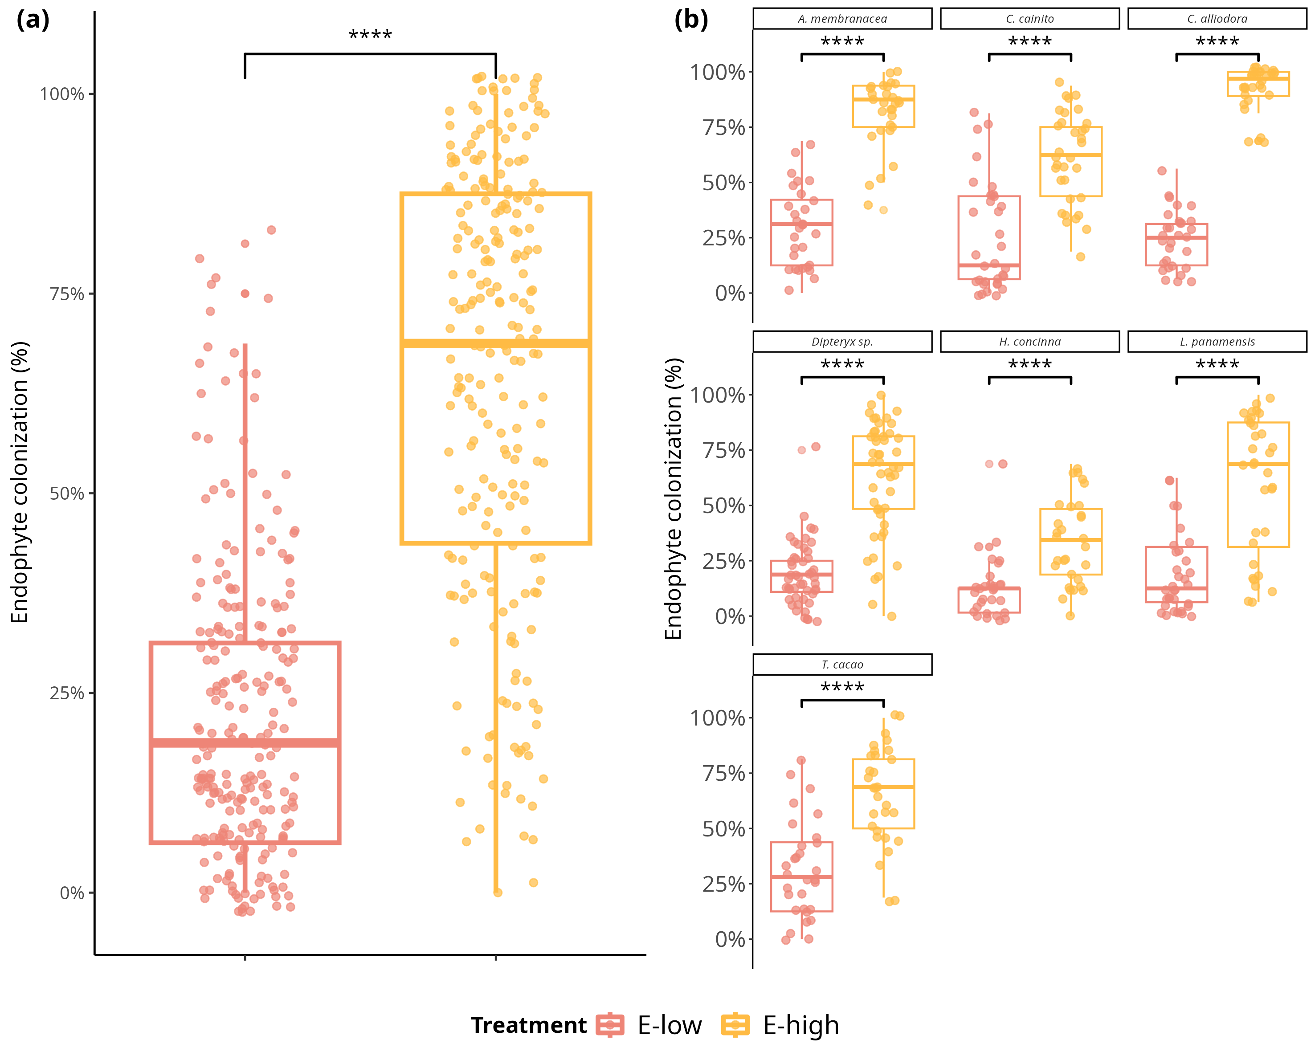

Foliar endophytic fungi (FEF) colonization of seven tropical tree species in malt extract agar (MEA 2%). a) Comparison of mean percent colonization of leaves by FEF measured 7 days after placing leaf pieces on plates. Statistical significance was calculated with a Student’s t-Test. Violin plots show the distribution of colonization values for all tree species within treatment groups (*E-low* and *E-high*). b) Comparison of mean percent colonization of leaves by FEF measured 7 days after culture. Violin plots show the distribution of percent colonization values for each species per treatment group. Pink filled violins represent low FEF group (*E-low*) and yellow filled violins represent high FEF group (*E-high*). Significance levels are represented by *ns* (not significant) and asterisks [*p* < .05 (*), *p* < .01 (**), p < .001 (***)*,* and *p* < .0001(****)].

## Figure S2

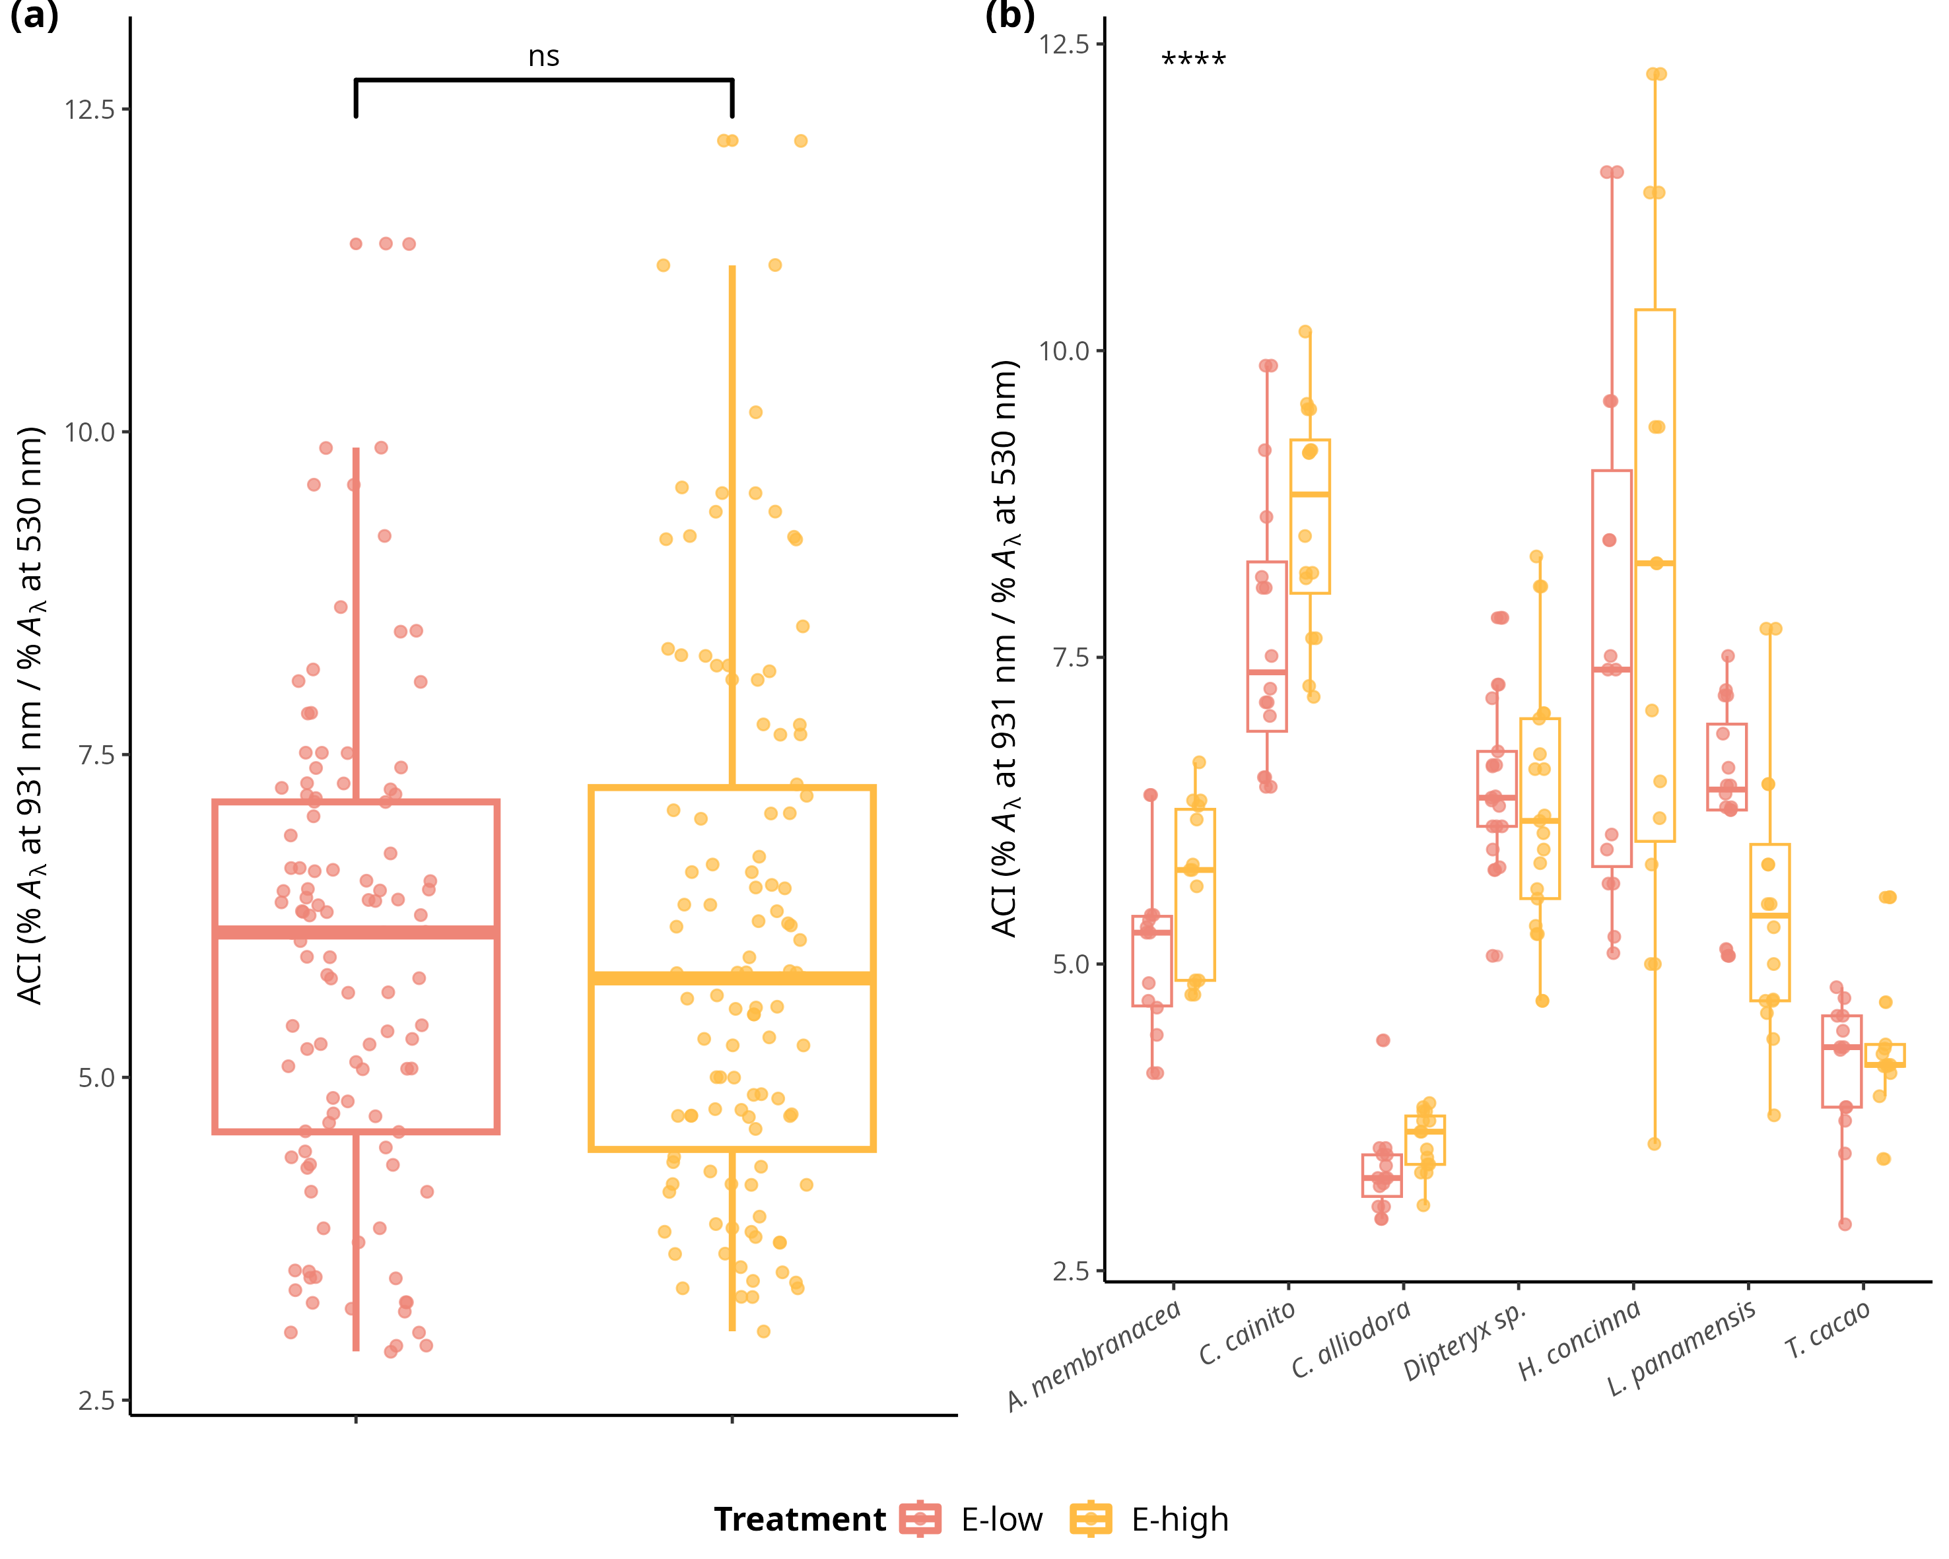

Distributions of values and means of anthocyanin content (ACI) in treatment groups (*E-low* and *E-high*) and tree species. a) Comparison of ACI means between treatment groups across individuals of all species. Statistical significance was calculated using a two-sided Student’s t-Test. b) Comparison of ACI means between treatment types of each species. Statistical significance was calculated with an analysis of variance (ANOVA). Pink filled violins represent low FEF group (*E-low*) and yellow filed violins represent high FEF group (*E-high*). Significance levels are represented by *ns* (not significant) and asterisks [*p* < .05 (*), *p* < .01 (**), p < .001 (***)*,* and *p* < .0001(****)].

## Figure S3

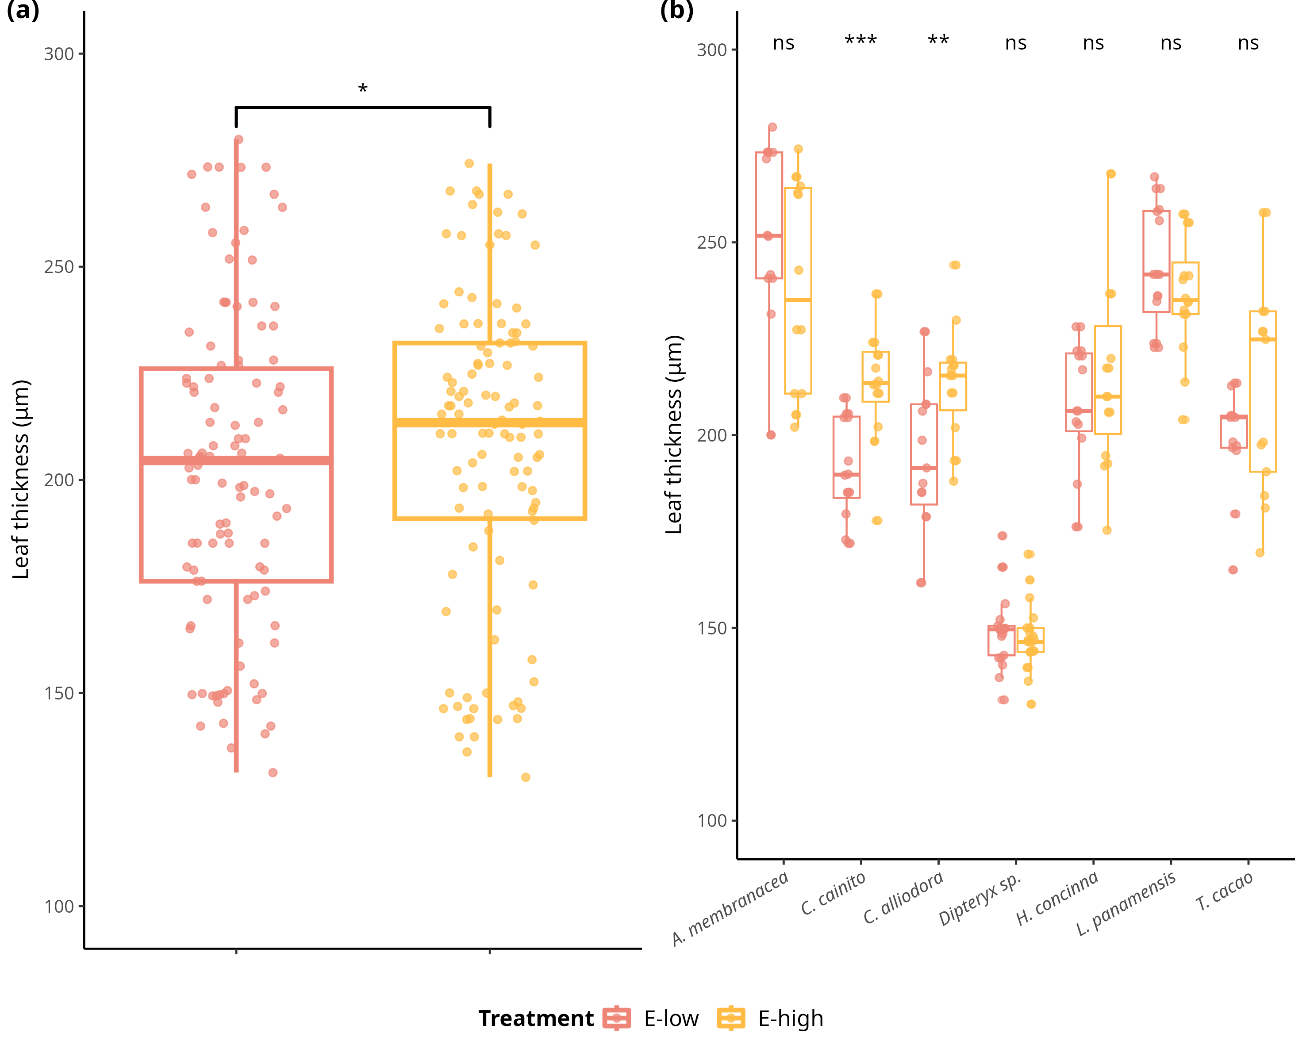

Distributions of values and means of leaf thickness (LT) (μg) in treatment groups (*E-low* and *E-high*) and tree species. a) Comparison of LT means between treatment groups across individuals of all species. Statistical significance was calculated using a two-sided Student’s t-Test. b) Comparison of LT means between treatment types of each species. Statistical significance was calculated with an analysis of variance (ANOVA). Pink filled violins represent low FEF group (*E-low*) and yellow filed violins represent high FEF group (*E-high*). Significance levels are represented by *ns* (not significant) and asterisks [*p* < .05 (*), *p* < .01 (**), p < .001 (***)*,* and *p* < .0001(****)].

## Figure S4

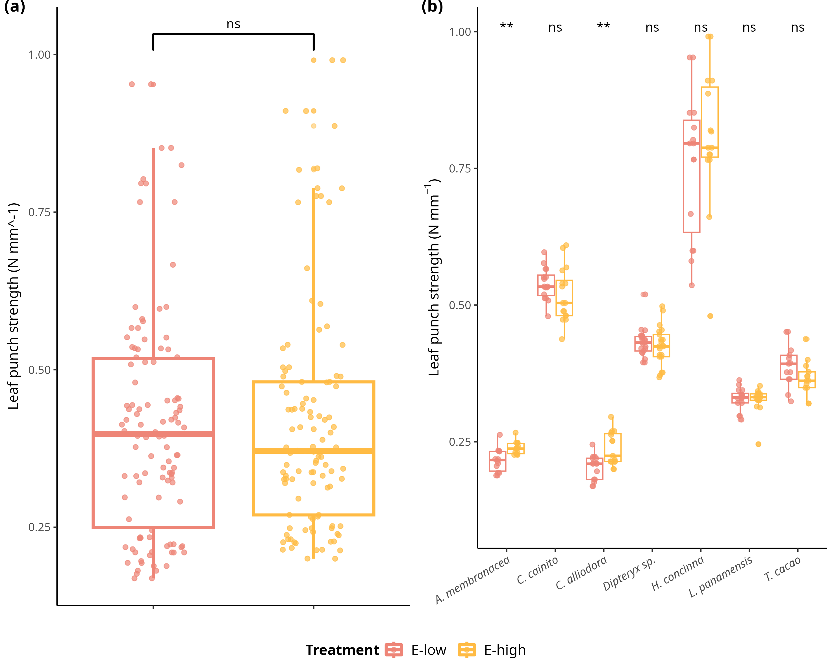

Distributions of values and means of leaf punch strength (LPS) (N mm^-1) in treatment groups (*E-low* and *E-high*) and tree species. a) Comparison of LPS means between treatment groups across individuals of all species. Statistical significance was calculated using a two-sided Student’s t-Test. b) Comparison of LPS means between treatment types of each species. Statistical significance was calculated with an analysis of variance (ANOVA). Pink filled violins represent low FEF group (*E-low*) and yellow filed violins represent high FEF group (*E-high*). Significance levels are represented by *ns* (not significant) and asterisks [*p* < .05 (*), *p* < .01 (**), p < .001 (***)*,* and *p* < .0001(****)].

## Figure S5

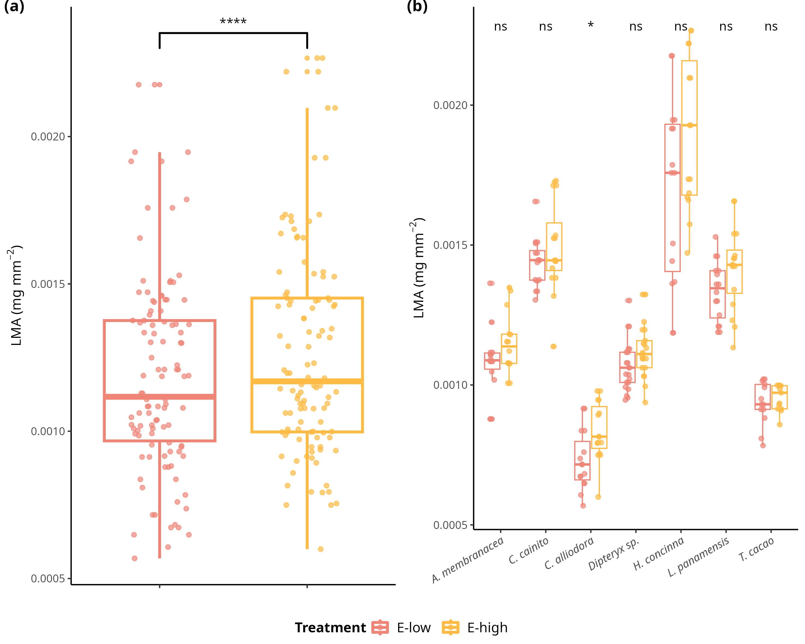

Distributions of values and means of leaf mass per area (LMA) (mg mm^2) in treatment groups (*E-low* and *E-high*) and tree species. a) Comparison of LMA means between treatment groups across individuals of all species. Statistical significance was calculated using a two-sided Student’s t-Test. b) Comparison of LMA means between treatment types of each species. Statistical significance was calculated with an analysis of variance (ANOVA). Pink filled violins represent low FEF group (*E-low*) and yellow filed violins represent high FEF group (*E-high*). Significance levels are represented by *ns* (not significant) and asterisks [*p* < .05 (*), *p* < .01 (**), p < .001 (***)*,* and *p* < .0001(****)].

## Figure S6

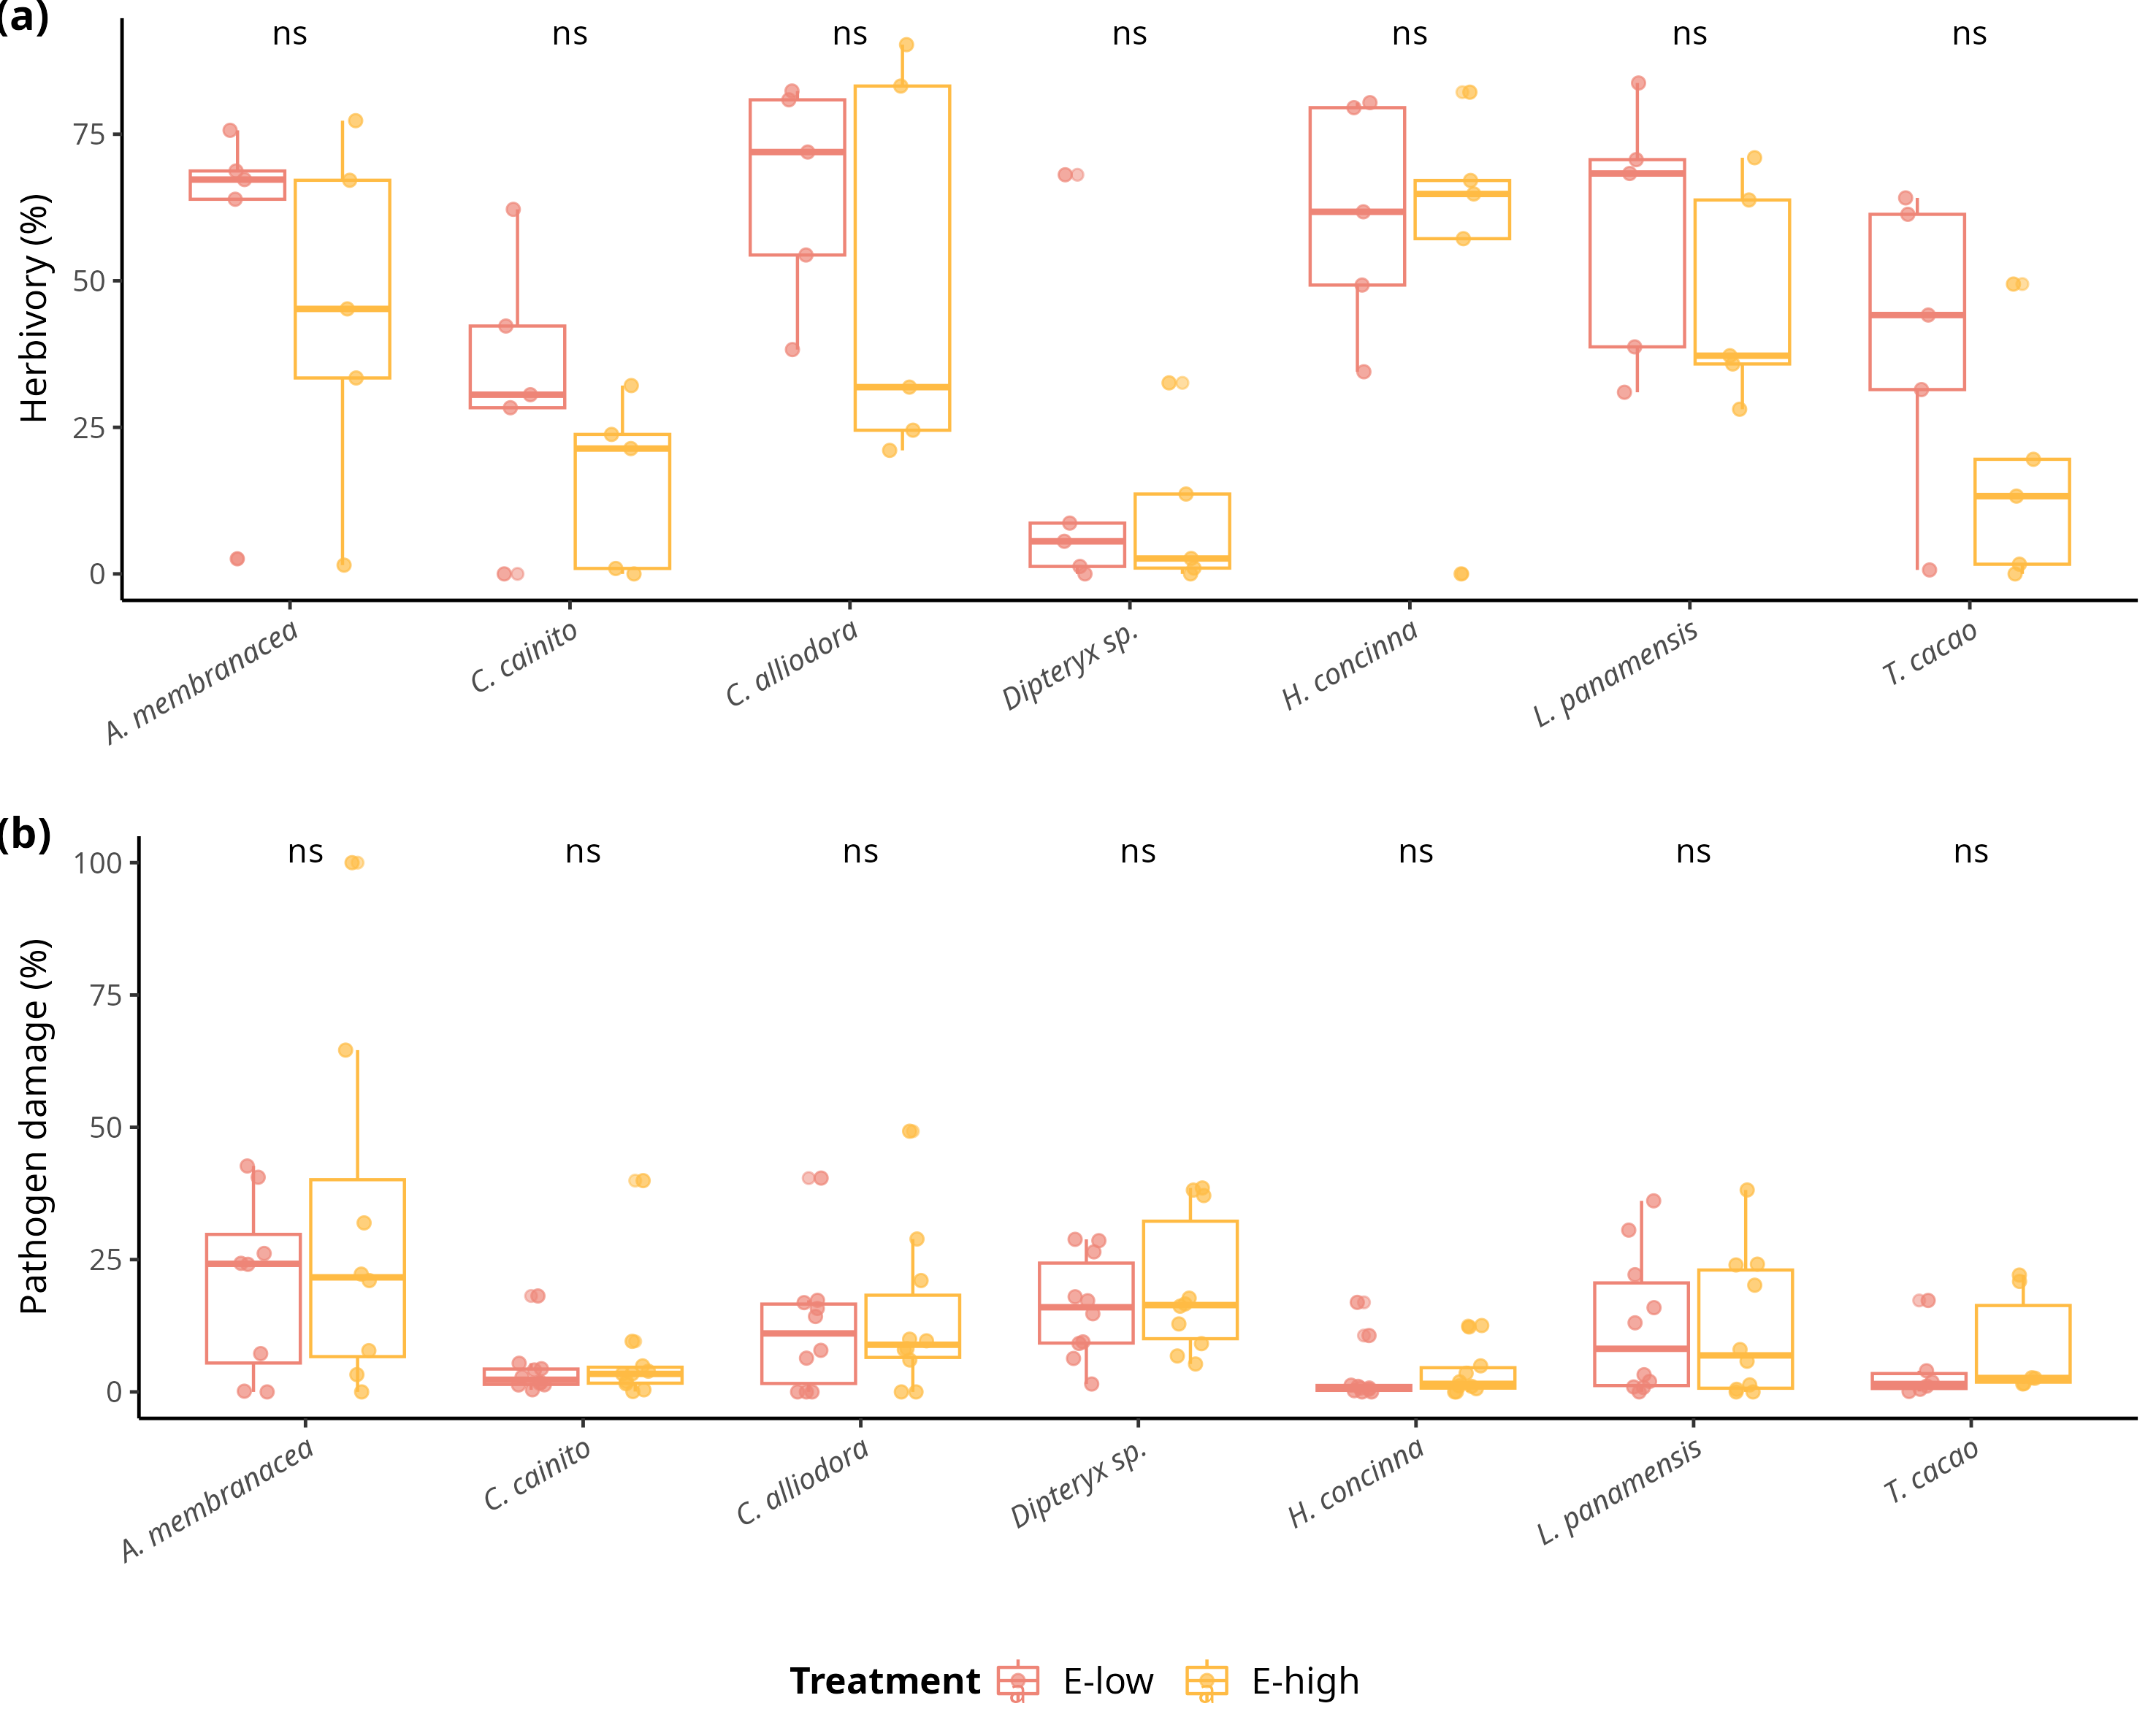

Distributions of values and means of herbivory (%) and pathogen damage caused by *Atta colombica* and *Calonectria* sp. , respectively, in treatment groups (*E-low* and *E-high*) per tree species. a) Comparison of herbivory (%) means between treatment groups across individuals of all species. b) Comparison of pathogen (%) means between treatment groups across individuals of all species. Pink filled violins represent low FEF group (*E-low*) and yellow filed violins represent high FEF group (*E-high*). Statistical significance was calculated with an analysis of variance (ANOVA). Significance levels are represented by *ns* (not significant) and asterisks Significance levels are represented by *ns* (not significant) and asterisks [*p* < .05 (*), *p* < .01 (**)*,* p < .001 (***)*,* and *p* < .0001(****)].

## Figure S7

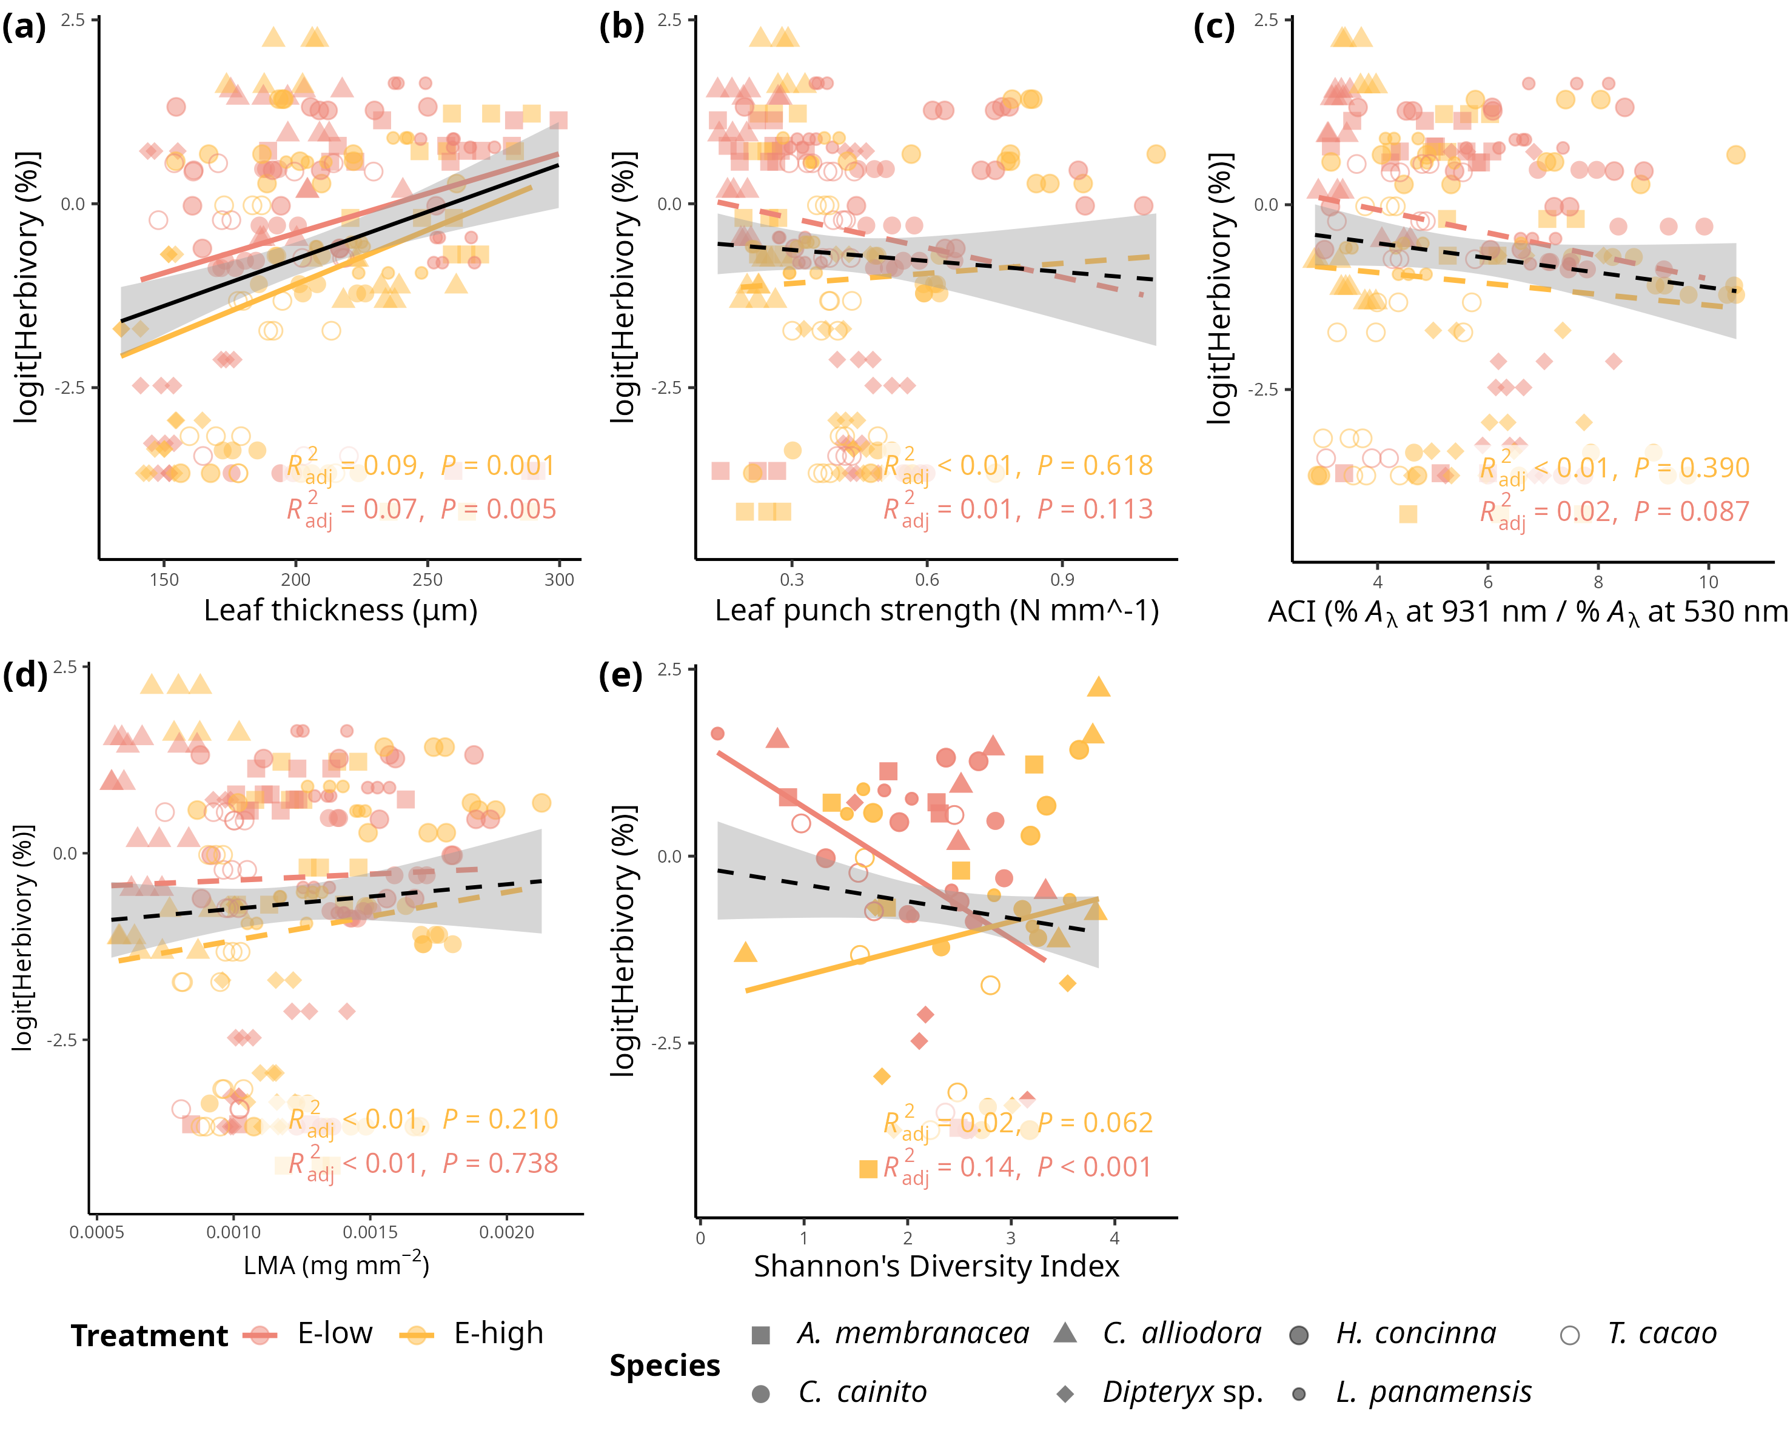

Simple linear regressions of logit transfomed herbivory (%) and and leaf functional traits. a) Herbivory *vs.* leaf thickness (LT) (μg) (R2-adjusted= 0.0811, *p* < .0001). b) Herbivory *vs.* LPS (N mm-1) (R2-adjusted= -0.0018, *p* = 0.429)). c) Herbivory *vs.* ACI (R2-adjusted= 0.0071, *p* = 0.116). d) Pathogen *vs.* LMA (mg mm^2) (R2-adjusted= -0.0008, *p* = 0.36). e) Herbivory *vs.* Shannon diversity index (R2-adjusted= 0.007 , *p* = 0.12). Pink filled line and shapes represent low FEF group (*E-low*) and yellow filled line and shapes represent high FEF group (*E-high*). Black line represents the linear regression on all observations.

## Figure S8

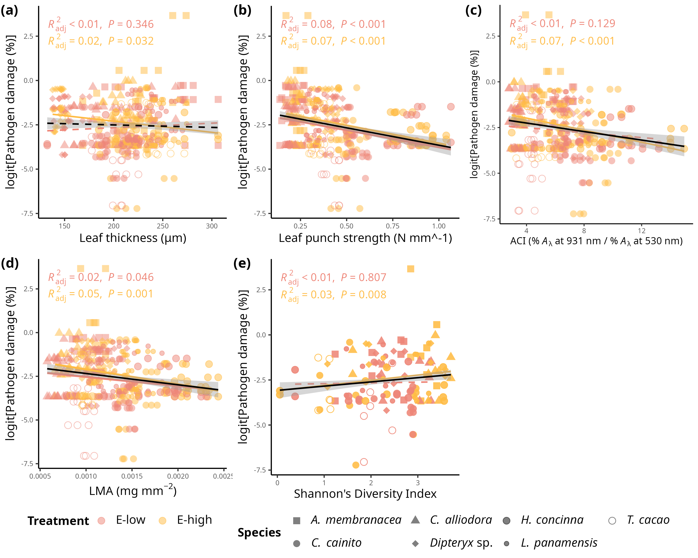

Simple linear regressions of logit transformed pathogen damage (%) and and leaf functional traits. a) Pathogen damage vs. leaf thickness (LT) (μg) (R2-adjusted= -0.0013, *p* = 0.482). b) Pathogen damage vs. LPS (N mm-1) (R2-adjusted= 0.0782, *p* < .0001)). c) Pathogen damage vs. ACI (R2-adjusted= 0.0338, *p* < .001). d) Pathogen vs. LMA (mg mm^2) (R2-adjusted= 0.0295, *p* < .001). e) Pathogen damage vs. Shannon diversity index (R2-adjusted= 0.0152 , *p* < .001). Pink filled line and shapes represent low FEF group (E-low) and yellow filled line and shapes represent high FEF group (E-high). Black line represents the linear regression on all observations.

## Figure S9

|  |
| --- |
| Simple linear regression on even and tiered mock FEF communities. |

Simple linear regression of tiered mock community.

## Supplementary Material - Methods

#### Seed collection and sterilization

Seeds were prepared for germination within 24 hours of fruit collection on BCI, January - April 2019. Fruits were peeled to extract seeds, cleaned, put in water to swell embryo, sterilized, and planted in sterile soil germination trays (75% soil; 25% sand). Soil was autoclaved at 121 °C in two, one hour cycles. Seeds were surface sterilized using 10% bleach for 3 minutes followed by 70% ethanol for 3 minutes.

#### Germination Tray and 24-pot tray sterilization

Plastic germination trays and 24-cell trays were sterilized in a 10% bleach bath for 20 minutes, sprayed with 70% ethanol, and paper towel dried right before adding soil/planting.

#### Planting in germination trays

The sterile soil is added to an sterilized plastic germination tray, combined with water well until it is wet and has a cookie dough-like consistency. Seeds were then added to moist soil. A sprinkle of dry soil is added to as a top layer to discourage pathogen spores from landing in the wet surface soil.

#### Seedling transfer into pots

Once seeds germinated, seedlings were transferred to pots by wetting the soil and extracting intact root system. Seedling were immediately placed in pot with sterile soil using a small shovel after uprooting from germination tray. Hands were sprayed with 70% ethanol when switching from handling one species to handling another. Plants were watered as needed at the soil level and 25mL of MiracleGro all-purpose plant food was added to every seedling once a month throughout entirety of experiment.

## Custom script for decontamination of samples

```{r}

library(dplyr)

library(tibble)

plate1 <- as.data.frame(plate1) # Ensure plate1 is a data frame plate1 <- column_to_rownames(plate1, var = "Sample_names") # Set row names

# add column with sums for each OTU

cont <- row.names(plate1)

cont <- cont[92:94] #change accordingly to your data - these are the negative controls

contamination <- c()

for (c in 1:ncol(plate1)) {

contamination[c] <- mean(plate1[rownames(plate1) %in% cont, c], na.rm = TRUE)

}

plate1 <- rbind(plate1, contamination)

row.names(plate1)[95] <- "contamination" #change the name of row 104

###subtract total contaminants from each OTU, if it is a negative number make it 0

cont2 <- c(cont, "contamination")

row <- which(!rownames(plate1) %in% cont2)

for (r in row) {

for (c in 1:ncol(plate1)) {

if (plate1[r, c] > plate1["contamination", c]) {

new_reads <- plate1[r, c] - plate1["contamination", c]

plate1[r, c] <- new_reads

} else {

plate1[r, c] <- 0

}

}

}

```